- Create a new process by invoking the appropriate system call. Get the process identifier of the currently running process and its respective parent using system calls and display the same using a C program.
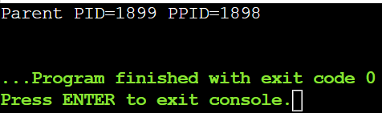
2 .Identify the system calls to copy the content of one file to another and illustrate the same using a C program.
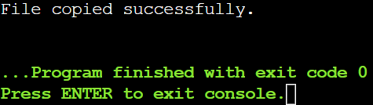
3. Design a CPU scheduling program with C using First Come First Served technique with the following considerations. a. All processes are activated at time 0. b. Assume that no process waits on I/O devices
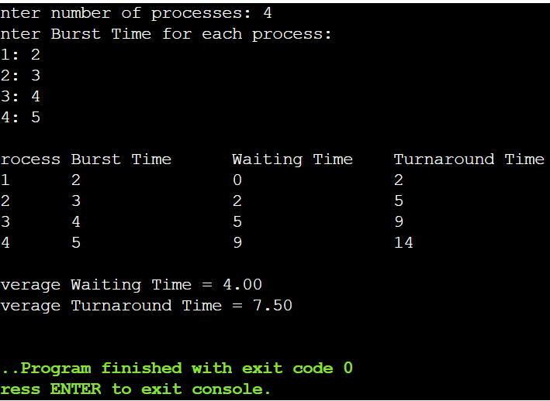
4 Construct a scheduling program with C that selects the waiting process with the smallest execution time to execute next
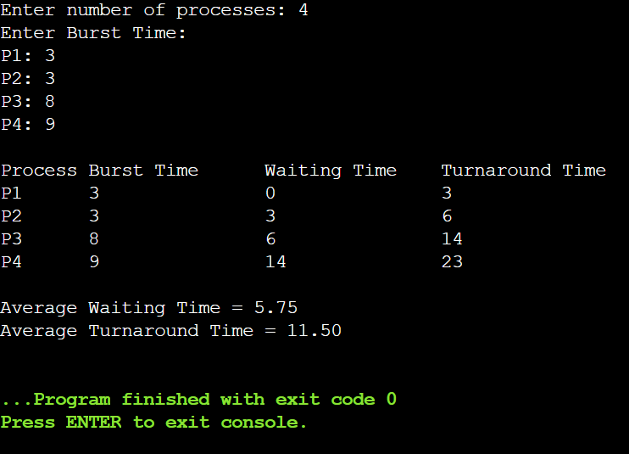
5 .Construct a scheduling program with C that selects the waiting process with the highest priority to execute next.
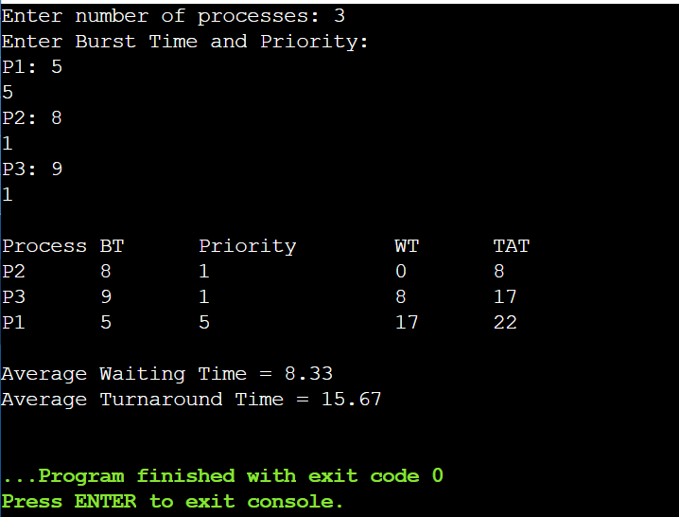

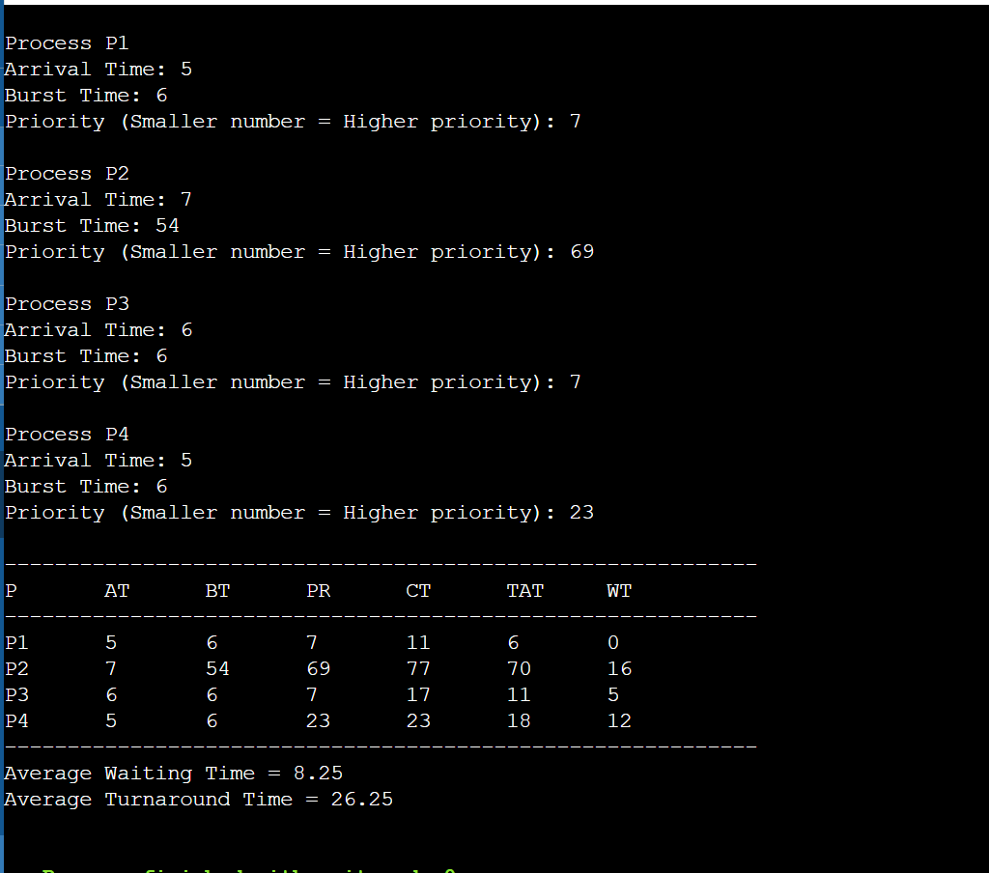
6 Construct a C program to implement preemptive priority scheduling algorithm

7 Construct a C program to implement a non-preemptive SJF algorithm.
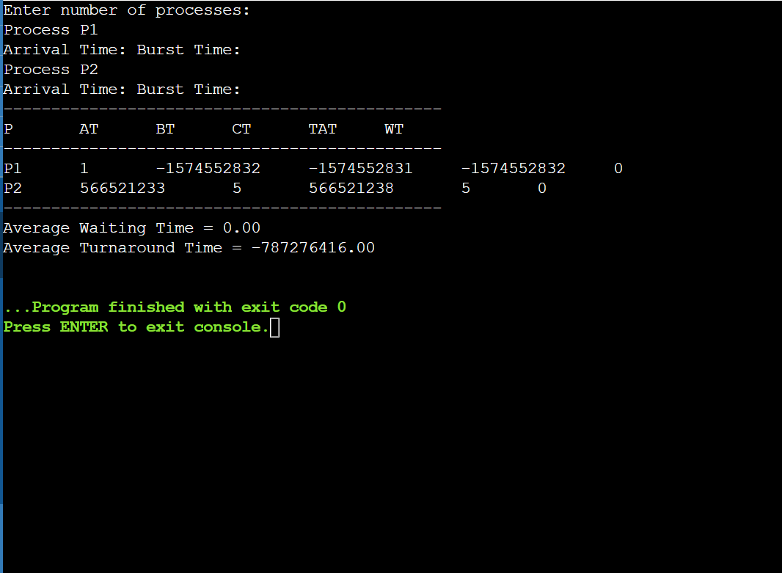

8 Construct a C program to simulate Round Robin scheduling algorithm with C.
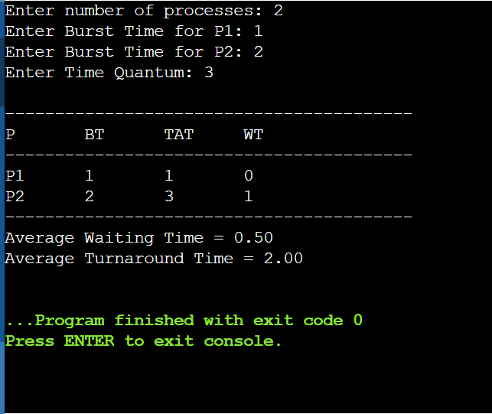
9 Illustrate the concept of inter-process communication using shared memory with a C program.
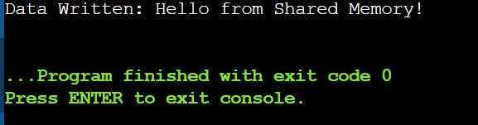
10 Illustrate the concept of inter-process communication using message queue with a C program.
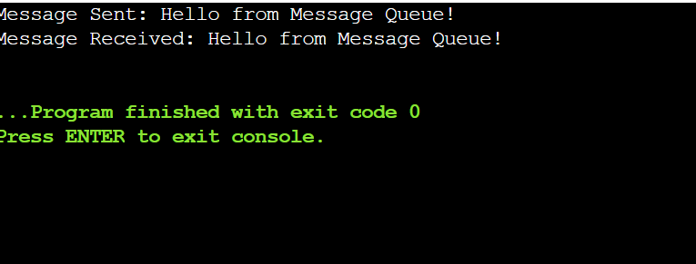
11 Illustrate the concept of multithreading using a C program.
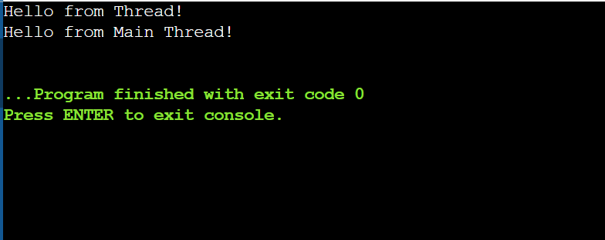
12 Design a C program to simulate the concept of Dining-Philosophers problem
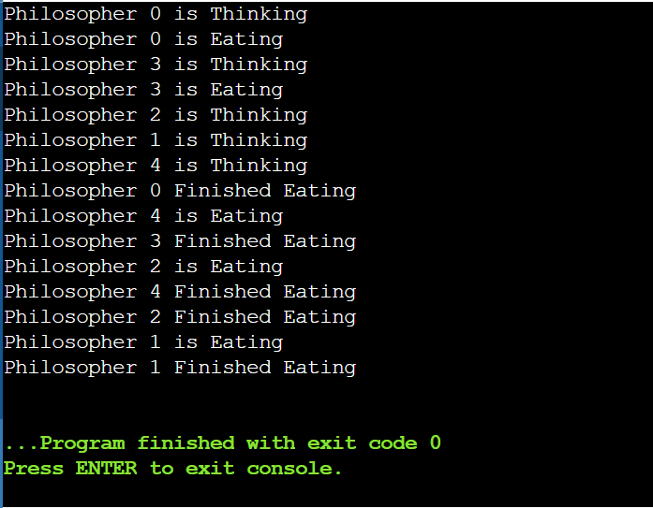
13 Construct a C program for implementation of the various memory allocation strategies.
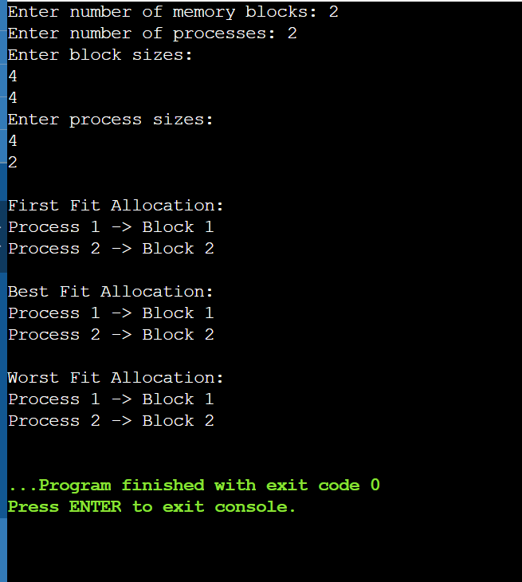
14 Construct a C program to organise the file using a single level directory.
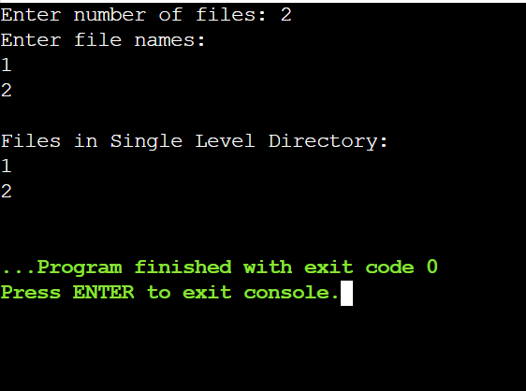
15 Design a C program to organise the file using a two level directory structure.
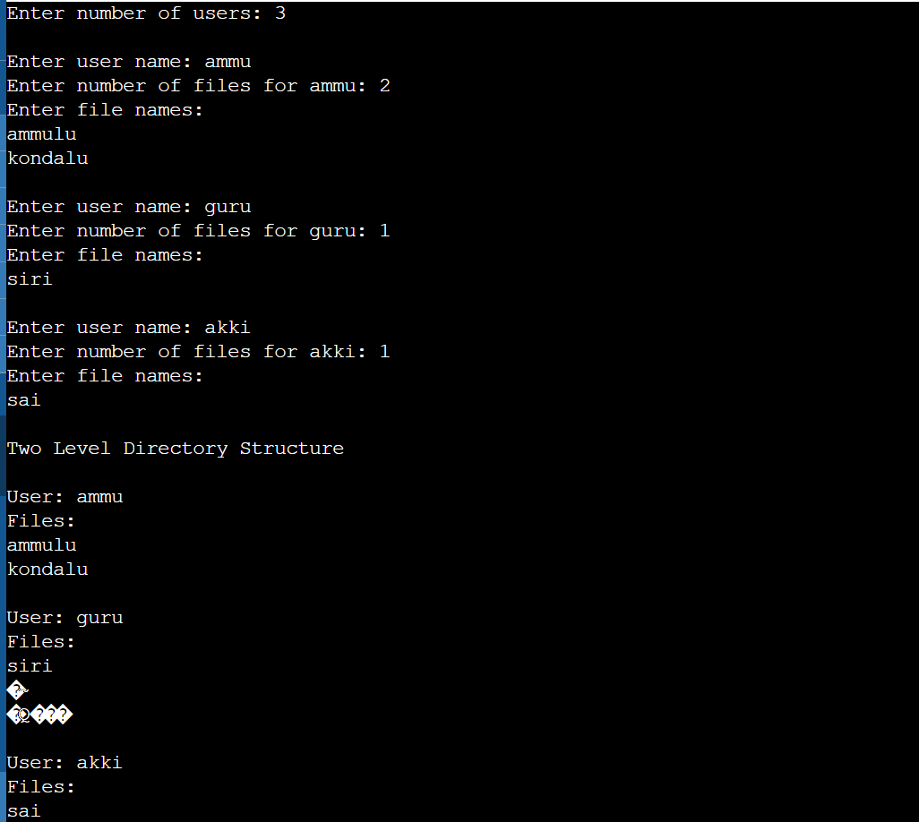
16 Develop a C program for implementing random access file for processing the employee details.
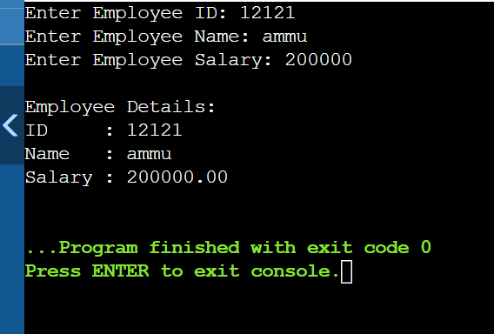
17 Illustrate the deadlock avoidance concept by simulating Banker’s algorithm with C.

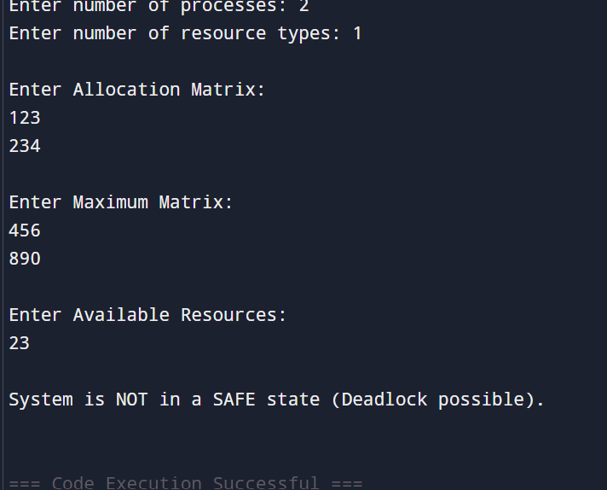

18 Construct a C program to simulate producer-consumer problem using semaphores.
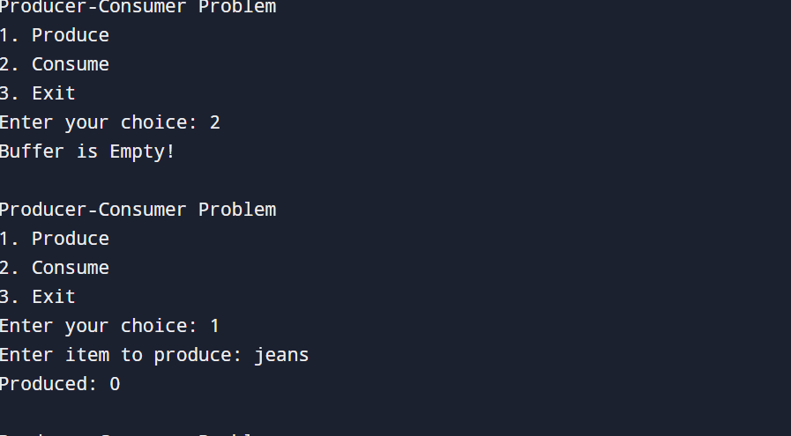

19 Design a C program to implement process synchronization using mutex locks.
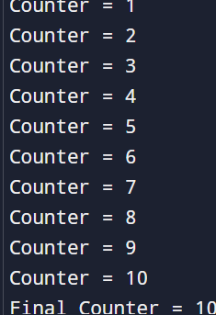
20 Construct a C program to simulate Reader-Writer problem using Semaphores.
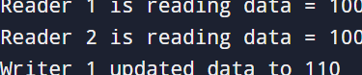

21 Develop a C program to implement the worst fit algorithm of memory management.
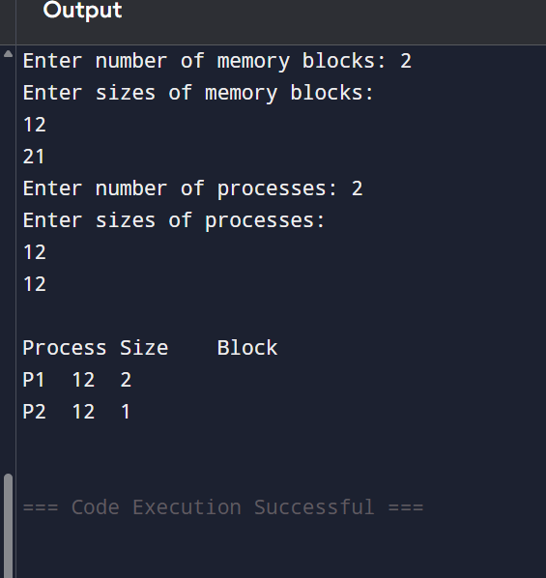
22 Construct a C program to implement the best fit algorithm of memory management.
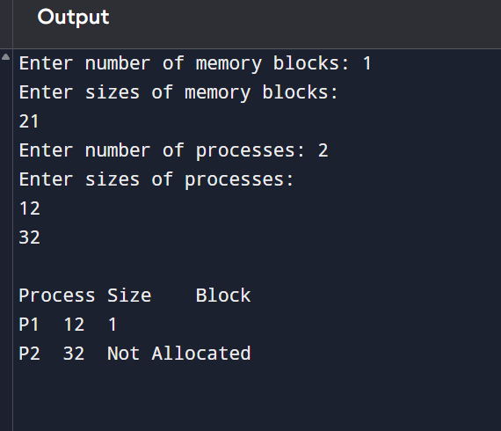

23 Construct a C program to implement the first fit algorithm of memory management.
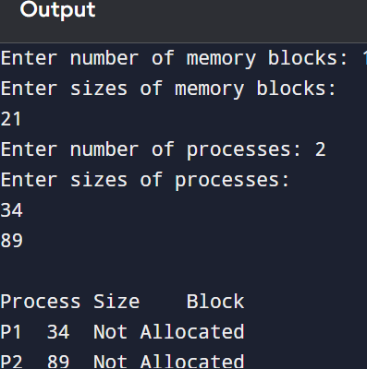
24 Design a C program to demonstrate UNIX system calls for file management.
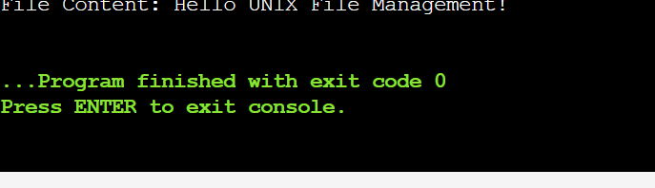
25 Construct a C program to implement the I/O system calls of UNIX (fcntl, seek, stat, opendir, readdir)
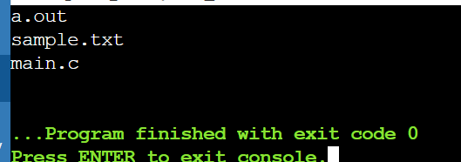

26 Construct a C program to implement the file management operations.
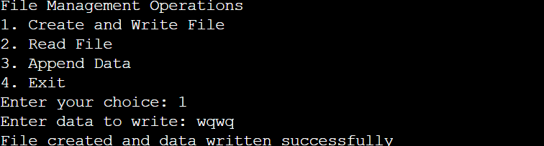

27 Develop a C program for simulating the function of ls UNIX Command.
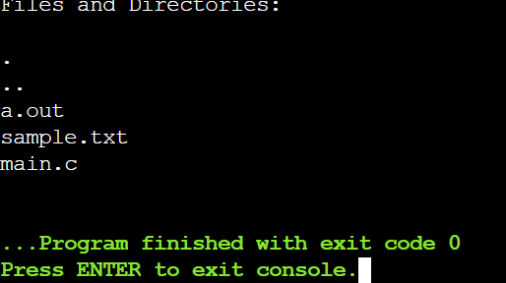
28 Write a C program for simulation of GREP UNIX command
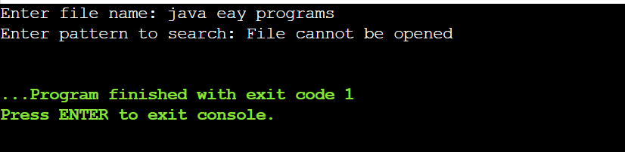

29 Write a C program to simulate the solution of Classical Process Synchronization Problem
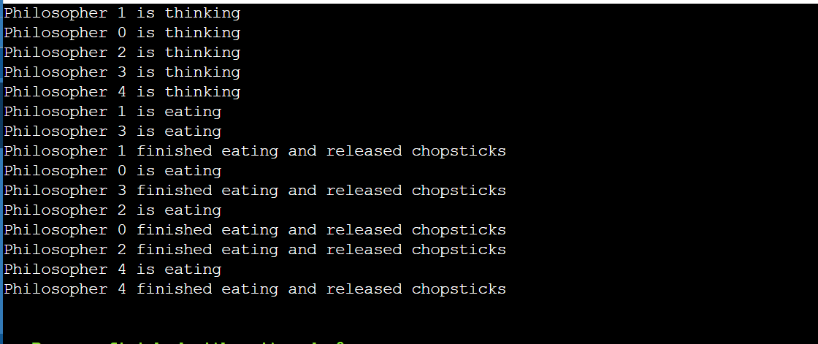
30 Write C programs to demonstrate the following thread related concepts. (i)create (ii) join (iii) equal (iv) exit
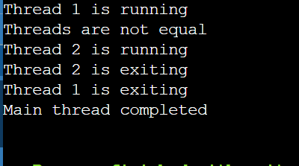
31 Construct a C program to simulate the First in First Out paging technique of memory management.
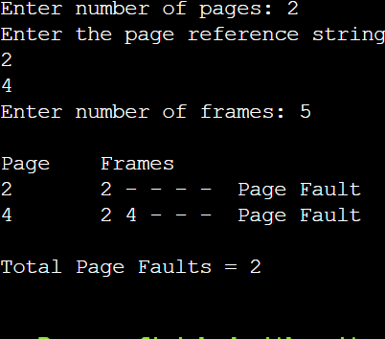
32 Construct a C program to simulate the Least Recently Used paging technique of memory management.
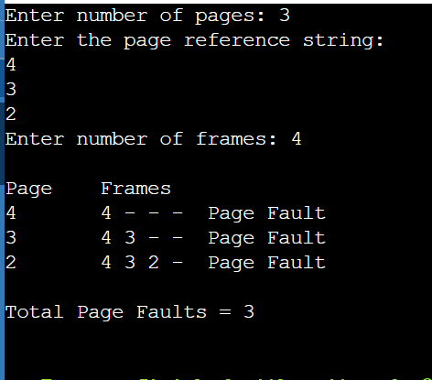

33 Construct a C program to simulate the optimal paging technique of memory management
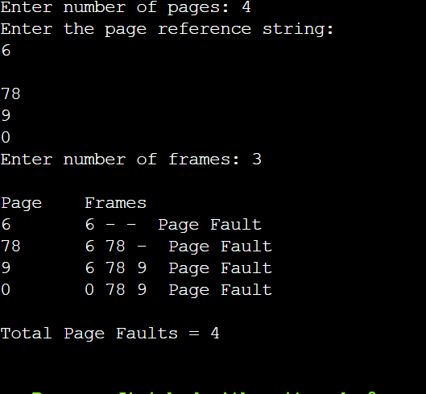

34 Consider a file system where the records of the file are stored one after another both physically and logically. A record of the file can only be accessed by reading all the previous records. Design a C program to simulate the file allocation strategy.
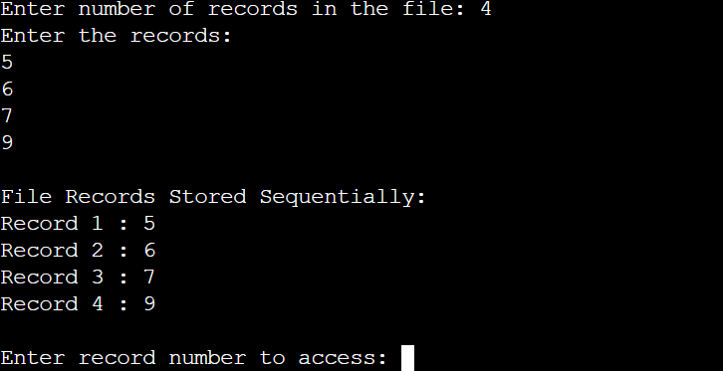
35 Consider a file system that brings all the file pointers together into an index block. The ith entry in the index block points to the ith block of the file. Design a C program to simulate the file allocation strategy.
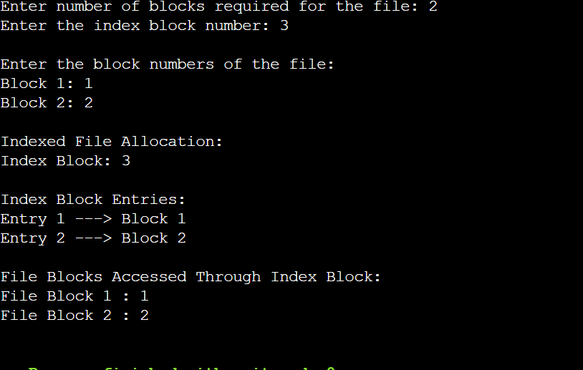
36 With linked allocation, each file is a linked list of disk blocks; the disk blocks may be scattered anywhere on the disk. The directory contains a pointer to the first and last blocks of the file. Each block contains a pointer to the next block. Design a C program to simulate the file allocation strategy.
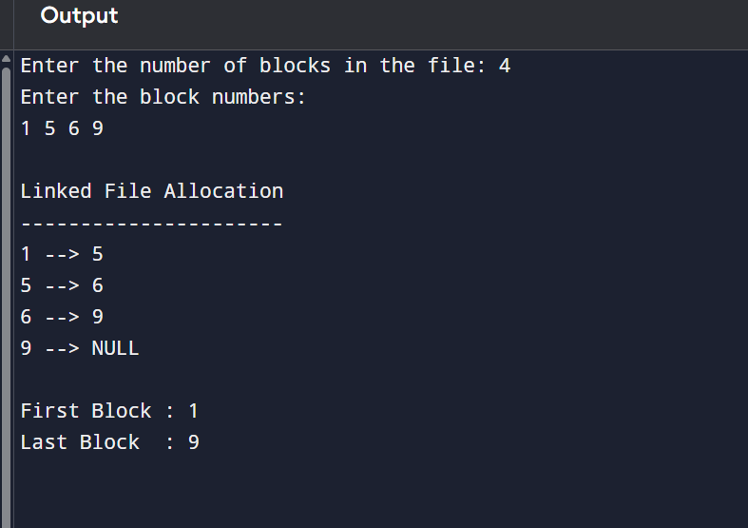
37 Construct a C program to simulate the First Come First Served disk scheduling algorithm.
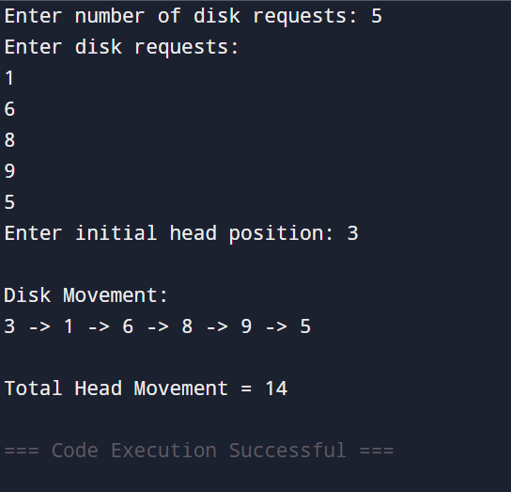

38 Design a C program to simulate SCAN disk scheduling algorithm.
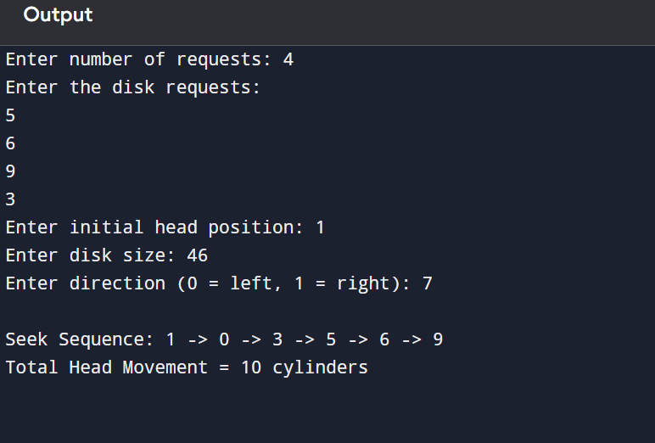
39 Develop a C program to simulate C-SCAN disk scheduling algorithm.
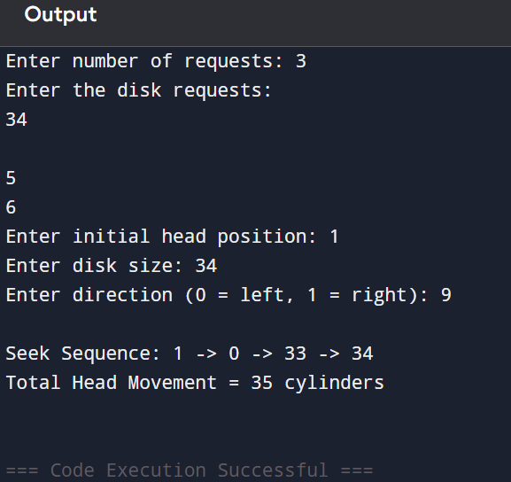

40 Illustrate the various File Access Permission and different types of users in Linux.
